Rid Board Feedback

* When looking at the “on location” section after sending a haul, it shows how much is required for the whole job and not what was sent. ——BUG073Fixed 1205

For example: a job needs 100t on location and I send 2 hauls, one 21t and one 26t, this is how it shows up:

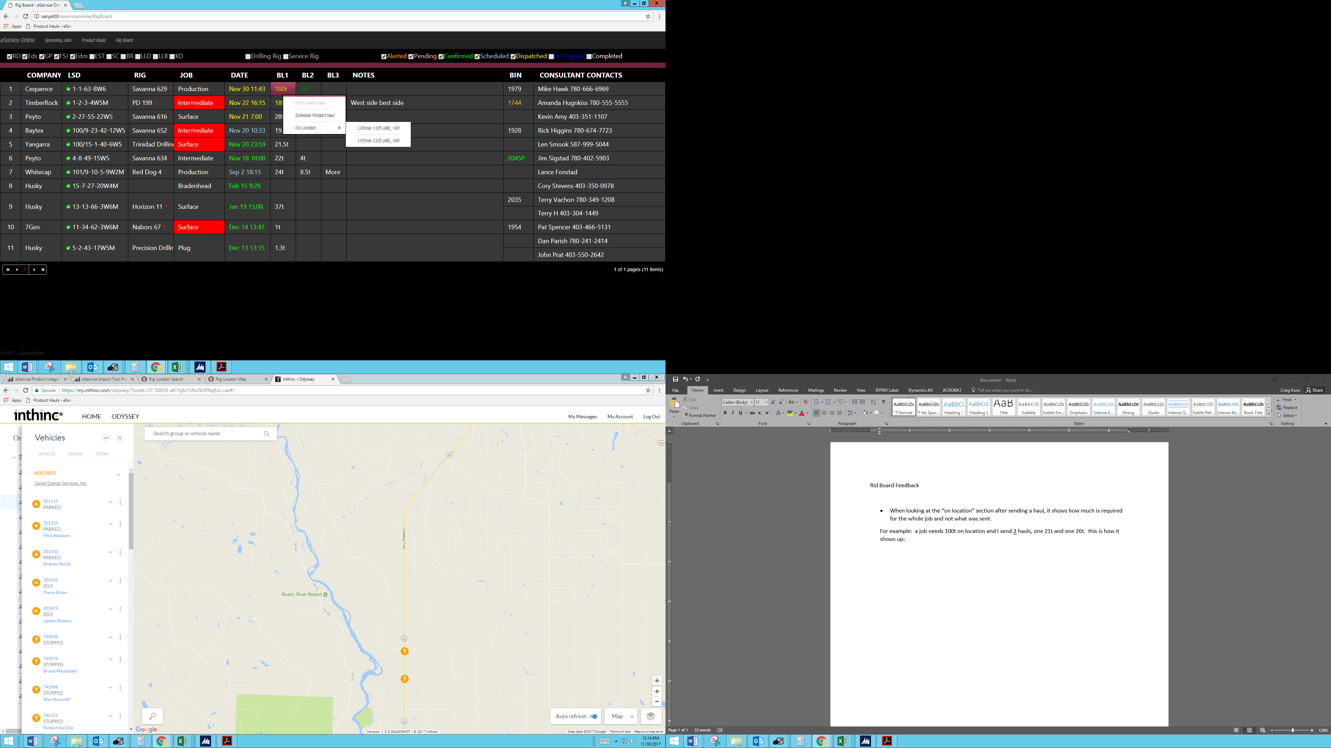

Notice how beside both “LITEmix 1325 (AB)” hauls it says 100. If you click on each haul you can find the amount shipped, but if the “100” instead showed how much was shipped it would be helpful.

* Not sure what the Bin colours mean

I will sort out Bin Section tommorrow

* Will bins stay with the rig? Or will they need to be entered every time?
* Changing the rig status doesn’t have any noticeable difference to the status (colour or symbol, ect.) If there is a “Deactivated” list, can we have access to it?

Dev team will work on rig job for “deactivated” rigs.

* Can we move the time status to “Scheduled” from “Confirmed” from the board?

No, it is automatically updated one call sheet is ready.

* Still feels somewhat awkward to find jobs without unchecking the completed jobs. Sorting through hundreds of jobs to find the one rig I’m looking for will get tiring.

Today’s version should be easier to go through with shorter list